Legal Owner:

Nubscrub Weinerhut Jr.

Legal Description:

2201 Collins Avenue
Miami Beach, FL 33139

Project Description:

- Construction of 2-story house with top deck as the social center
- Construction of a 2-car garage
- STYLE:
- Mediterranean/Beach
- Focus: A relaxing calm feel of the beach setting, Party house with featured party vicinities, Big, Eccentric, Made for adventure

Team Involved:

PROJECT MANAGER
Josh Shtein
(303) 794 2071

DRAFTER:
Lena Hilliard
(303) 298 4133

PLANNER/ESTIMATOR:

Josh Shtein
Lena Hilliard
Melissa Garabito

Melissa Garabito
(303) 550 1609

Sheet Index:

A-1: Title Page
A-2: Site Plan/Vicinity Map
A-3: 1st Level Floor Plan
A-4: 2nd Level Floor Plan
A-5: Top Deck Floor Plan
A-6: Front/back Elevations
A-7: side views Elevations
A-8: Cost Estimate

Zone Information:

Zone: RS-1, Residential, Single Family Zoning District

MINIMUM SETBACKS:
Front: 20 ft.
Side: 15 ft.
Rear: 20 ft.

LOT AREA: 9094 sq. ft.

LIVABLE AREA:
First Floor: 2844 sq. ft.
Second Floor: 2824 sq. ft.
Top Deck: 1865 sq. ft. (Game room-104 sq. ft.)
TOTAL LIVABLE AREA: 5772 sq. ft. (No Top Deck)
GARAGE: 415 sq. ft.
A-1
F.A.R.: 70%

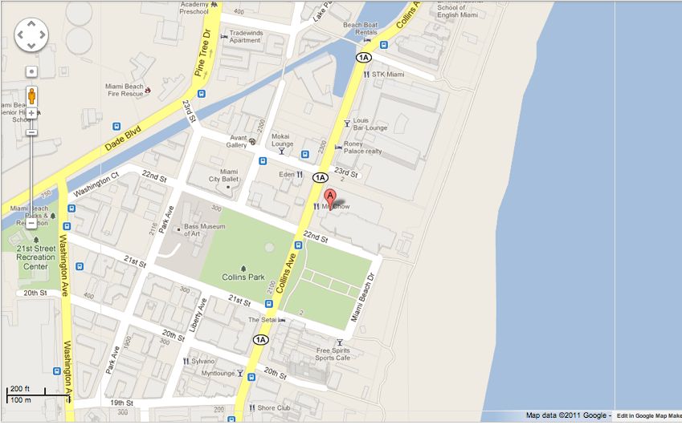

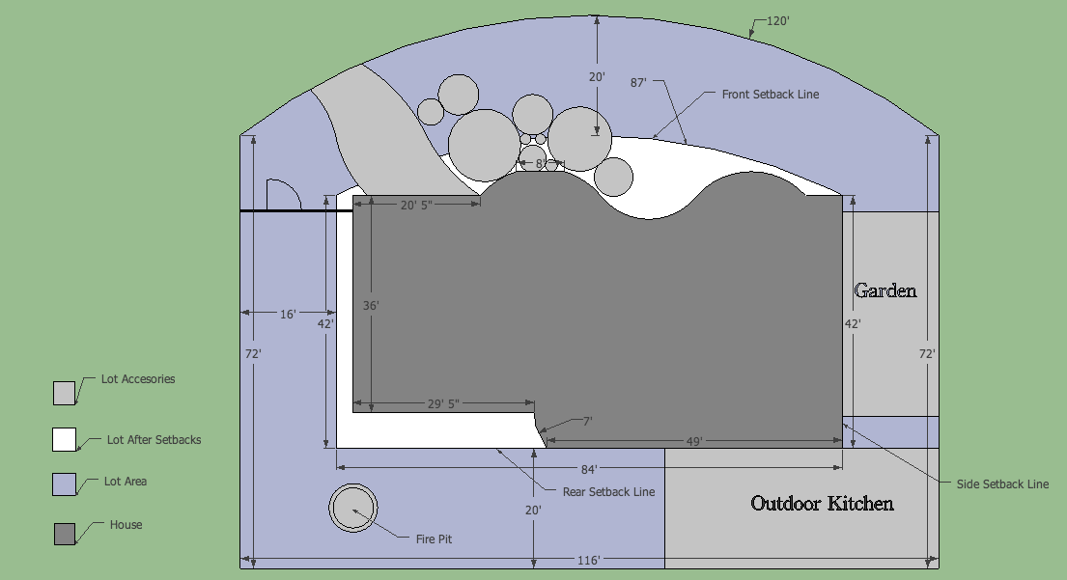

Josh Shtein
Lena Hilliard
Melissa Garabito

A-2

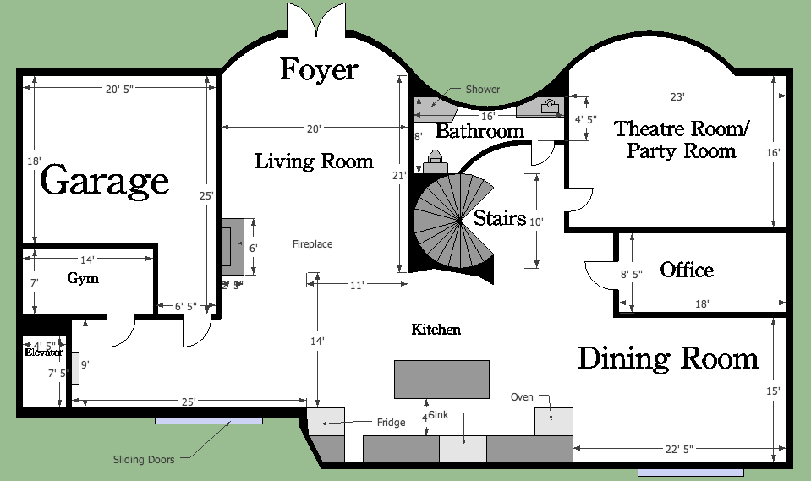

Josh Shtein
Lena Hilliard
Melissa Garabito

A-3

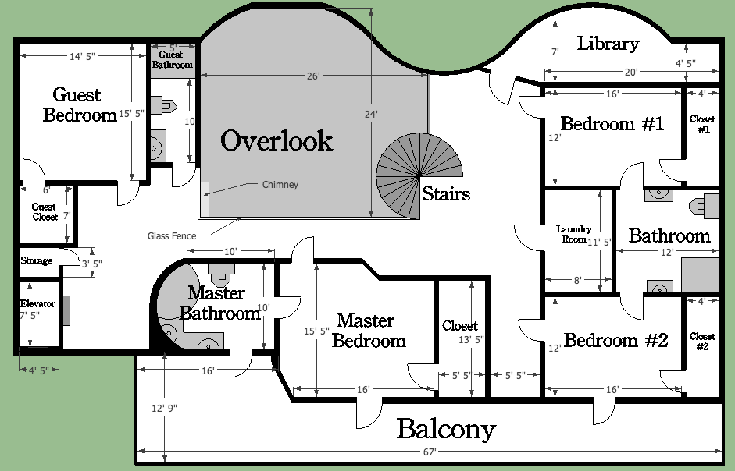

Josh Shtein
Lena Hilliard
Melissa Garabito

A-4

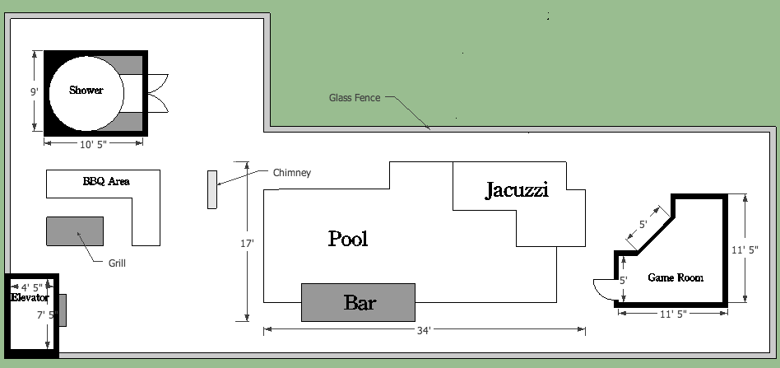

Josh Shtein
Lena Hilliard
Melissa Garabito

A-5

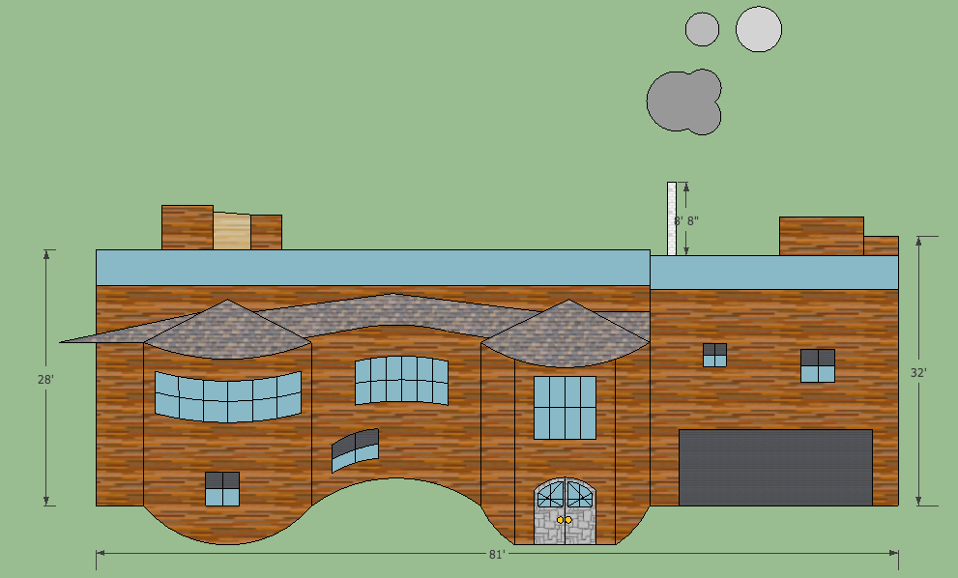

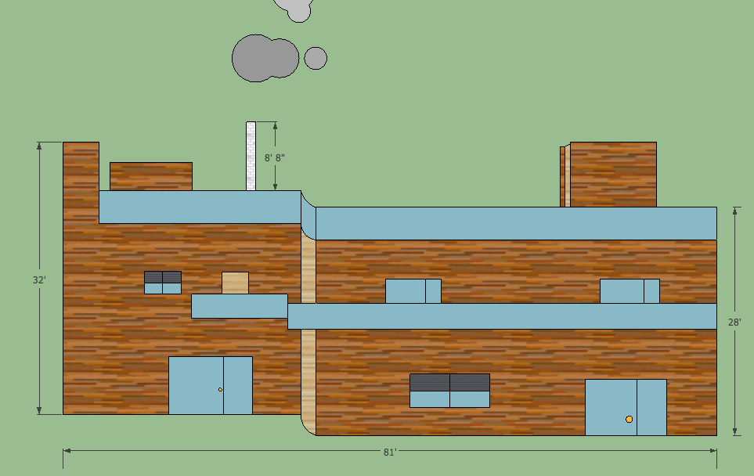

Josh Shtein
Lena Hilliard
Melissa Garabito

A-6

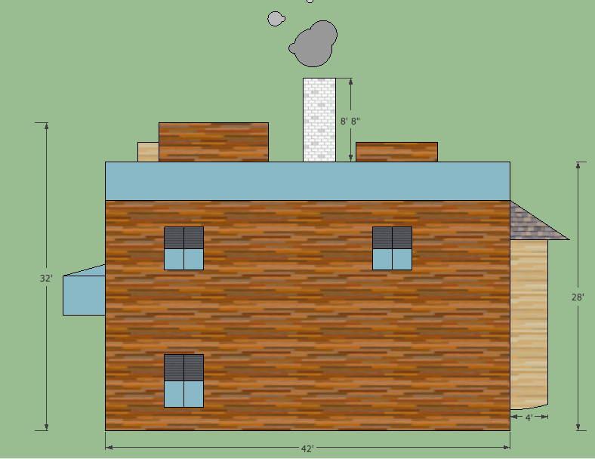

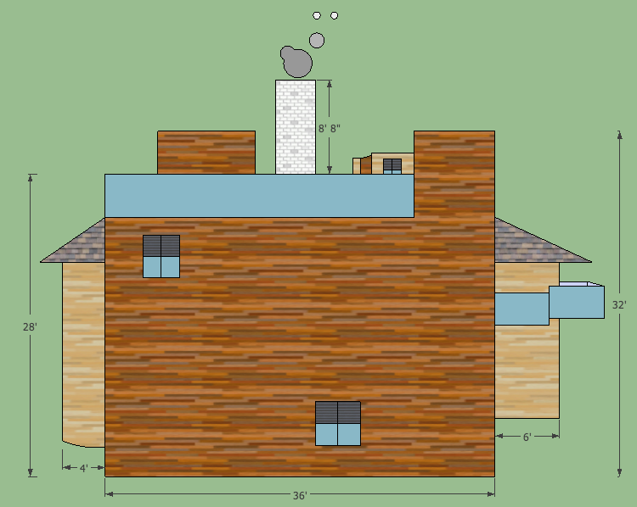

Josh Shtein
Lena Hilliard
Melissa Garabito

A-7

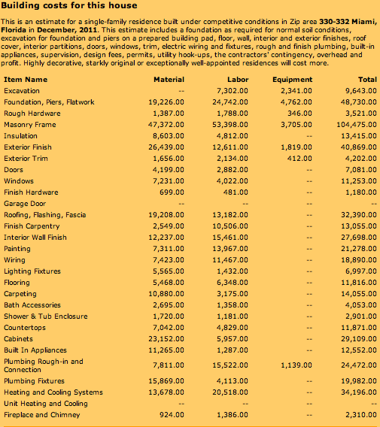

Josh Shtein
Lena Hilliard
Melissa Garabito

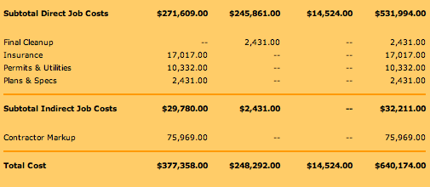
A-8

