On Twitter, Pope to get different type of followers
A5
FRIDAY, NOVEMBER 9, 2012 1-800-AMERICAN
$1.00 CITY & SUBURBS, $1.25 NATION-WIDE TOLL Subscribers receive standard rates and fees

Visit us at www.theamerican.org

ANALYSIS

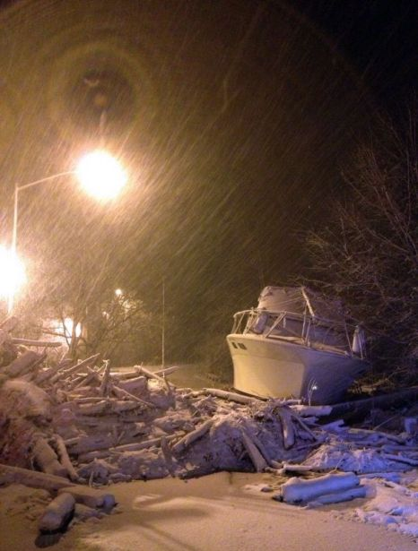
New York rations gasoline; Storm victims still in dark
By Daniel Trotta and David Sheppard
NEW YORK | Fri Nov 9, 2012 12:07pm EST
Two male dolls aligned side by side (DallasVoice.com)
Gay marriage votes could sway U.S. Supreme Court

The votes came two weeks before the Supreme Court justices are to meet, on November 20, to decide whether to review six gay rights cases that have been brought before the court.
Four of the cases test the constitutionality of the Defense of Marriage Act, or DOMA, which bars the federal government from recognizing same-sex marriages performed in states or foreign countries where they are allowed. Another seeks approval for A1AAProposition 8, a 2008 measure that outlawed same-sex marriage in California. The sixth case concerns gay rights in Arizona.
A critical question for the Supreme Court is how much political clout gays and lesbians have - and that's where Tuesday's votes could come into play.
ALERT
Banana Boat recalls sunscreen due to fire alert
The maker of Banana Boat sunscreen is recalling some half-million bottles of spray-on lotion after reports that a handful of people have caught on fire after applying the product and coming in contact with an open flame.
A4
ELECTION
Calif. Mayoral Candidate Arrested on Election Day
A Central Coast candidate for mayor lost big this week.
Paso Robles write-in candidate Jeff Rougeot was arrested on Election Day for investigation of crimes that include felonies for making brandishing a firearm.
A10

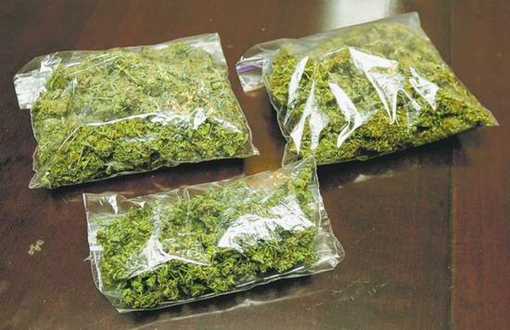
Pot votes in CO, WA raise specter of weed tourism
November 9, 2012 6:17 AM
By Associated Press
DENVER - Hit the slopes — and then a bong?
Marijuana legalization votes this week in Colorado and Washington state don't just set up an epic state-federal showdown on drug law for residents. The measures also open the door for marijuana tourism.
Both marijuana measures make marijuana possession in small amounts OK for all adults over 21 — not just state residents but visitors, too. Tourists may not be able to pack their bowls along with their bags, but as long as out-of-state tourists purchase and use the drug while in Colorado or Washington, they wouldn't violate the marijuana measures.
Of course, that's assuming the recreational marijuana measures take effect at all. That was very much in doubt Friday as the states awaited word on possible lawsuits from the U.S. Department of Justice asserting federal supremacy over drug law.
So the future of marijuana tourism in Colorado and Washington is hazy. But that hasn't stopped rampant speculation, especially in Colorado, where tourism is the No. 2 industry thanks to the RockyRovckMountains and a vibrant ski industry.
The day after Colorado approved recreational marijuana by a wide margin, the headline in the Aspen Times asked, "Aspendam?" referring to Amsterdam's marijuana cafes.
Colorado's tourism director, Al White, tried to downplay the prospect of a new marijuana tourism boom.
"It won't be as big a deal as either side hopes or fears," White said.
Maybe not. But many are asking about marijuana tourism.
Bags filled with marijuana plant (Photo: AnimalNewYork.com)
employment, a measure put into place to ensure "the highest ethical behavior."
Rear Admiral Garry Bonelli, the deputy commander of Naval Special Warfare Command, said the Navy treats allegations of misconduct seriously and also enforces nondisclosure agreements signed by sailors who join the special operations forces.
"We do not tolerate deviations from the policies that govern who we are and what we do as sailors in the United States Navy," he said in a statement after the administrative punishment was handed down.
"The non-judicial punishment decisions made today send a clear message throughout our force that we are and will be held to a high standard of accountability," he said.
The punishment of the seven active-duty SEALS comes about two months after the Pentagon threatened to take legal action against former U.S. Navy SEAL Matt Bissonnette for writing an unauthorized book about the 2011 commando raid that killed bin Laden.
The Pentagon said the book "No Easy Day," written under the pen name Mark Owen, had been published in violation of nondisclosure agreements Bissonnette signed while a SEAL.
Bissonnette's attorneys and publishers insisted the book had been carefully reviewed to ensure it disclosed no classified information, and that he had fulfilled his duty.
(Reporting By David Alexander, Phil Stewart and Mark Hosenball; Editing by Mohammad Zargham)

WASHINGTON (Reuters) - Seven members of an elite U.S. Navy SEAL team, including one who participated in the raid that killed al Qaeda leader Osama bin Laden, have been reprimanded for disclosing classified material while helping produce a videogame, officials said on Thursday.
All seven of the special operations forces who were punished were members of the elite SEAL Team Six, according to CBS News, which first reported the reprimands. CBS said the seven worked for two days this spring and summer as paid consultants on the videogame.
A U.S. official, speaking on condition of anonymity, confirmed the details of the account. A defense official, also speaking on condition of anonymity, said other members of the team are still under investigation in connection with the game.
Two senior chief special operators and five chief special operators received a reprimand on Wednesday for their involvement in the production of a videogame entitled "Medal of Honor: Warfighter," released by gamemaker Electronic Arts Inc, said a Navy official, who spoke on condition of anonymity.
All seven were punished in an administrative proceeding for disclosing classified information and misusing command gear while working with the gamemakers, who advertise that the videogame is more accurate because of the help they had from special operations forces.
The seven each received a punitive letter of reprimand and were docked half pay for two months, a Navy official said. A defense official said all Pentagon employees are required to follow Defense Department guidance on outside

The American Ambassador

Thu Nov 8, 2012 10:52pm EST
Seven Navy SEALS reprimanded for actions linked to videogame
THINKING

Continued A6
Continued A3
NEW YORK (Reuters) - New York City began rationing gasoline on Friday for the first time since the energy shortages of the 1970s, seeking to ease a fuel crisis in the U.S. Northeast brought on by devastating Superstorm Sandy.
The former hurricane that hammered the East Coast on October 29 killed at least 120 people and caused an estimated $50 billion in damage or economic losses.
It also disrupted the fuel supply chain, creating hours-long waits for gasoline that led officials first in New Jersey and now New York City and Long Island to impose rationing that allows only cars with odd- or even-numbered license plates to buy gas on any single day.
"This is worse than the oil crises of the 1970s," said Ralph Bombardiere, executive director of the New York State Association of Service Stations and Repair Shops. "Back then there was just a perceived shortage of supply in New York, when there was plenty gasoline around. Now we're having real distribution problems." The long lines at the pump have added to the frustration of commuters, who must choose between driving and enduring seemingly interminable waits for buses and trains with parts of the transportation network still businesses in the Northeast lacked power as of Thursday night, creating more misery for the thousands forced to flee their storm-damaged homes or for those who have hunkered down in the dark with freezing overnight temperatures.
Grounded: A boat washed ashore by Superstorm Sandy is covered in snow by the latest storm (Photo: AP)

