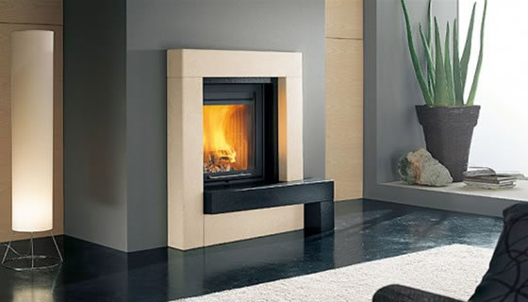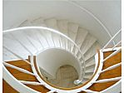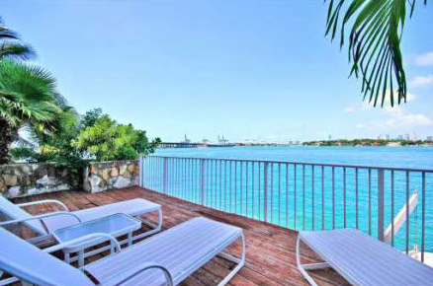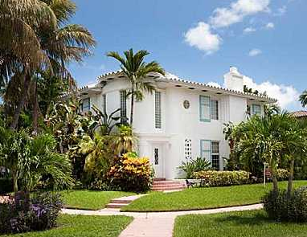

Nubsrub Weinerhut Jr.

Melissa, Lena, and Josh

Price starting at $640,174.00

Now available, is a beautiful new home with luxury feel. Located on the warm Miami Beach, this modern home has four bedrooms and four full baths. Some special features include a spiral staircase, an elevator, and a rooftop pool. Completed with a stable cedar deck to catch views of the Florida sky. Includes a Jack and Jill bath and a large master bedroom. This home is an opportunity not to be missed.